Class Activity 2 - MC

NAME:N.AKSHAYA
REG.NO:192425129
COURSE CODE:MLA0305
COURSE NAME:REINFORCEMENT LEARNING

R-CODE:
# MONTE CARLO METHOD - REAL TIME EXAMPLE
# Example: Daily Coffee Shop Profit Estimation
# One Complete R Program
# Clear Console
cat("\014")
set.seed(123)
# REAL-TIME DATA
days <- paste("Day",1:10)
daily_profit <- sample(seq(450,900,50),10,replace=TRUE)
# PROCESS 1 : EPISODE
cat("====================================================\n")
cat("PROCESS 1 : EPISODE\n")
cat("====================================================\n\n")
cat("Explanation:\n")
cat("Each episode represents one working day in a coffee shop.\n")
cat("Every day has a different profit depending on customer visits.\n\n")
episode_colors <- rainbow(length(daily_profit))
bp <- barplot(daily_profit,
names.arg=days,
col=episode_colors,
border="black",
main="Episode: Daily Coffee Shop Profit",
xlab="Working Days",
ylab="Profit (Rs)",
ylim=c(0,max(daily_profit)+150))
text(bp,daily_profit,
labels=daily_profit,
pos=3,
cex=0.8)
readline("Press ENTER to Continue...")
# PROCESS 2 : COLLECT REWARDS
cat("\014")
cat("====================================================\n")
cat("PROCESS 2 : COLLECT REWARDS\n")
cat("====================================================\n\n")
cat("Explanation:\n")
cat("The profit earned each day becomes the reward collected\n")
cat("by the Monte Carlo agent.\n\n")
reward <- daily_profit
reward_colors <- heat.colors(length(reward))
bp <- barplot(reward,
names.arg=days,
col=reward_colors,
border="black",
main="Collect Rewards (Daily Profit)",
xlab="Working Days",
ylab="Reward (Profit)",
ylim=c(0,max(reward)+150))
text(bp,reward,
labels=reward,
pos=3,
cex=0.8)
readline("Press ENTER to Continue...")
# PROCESS 3 : COMPUTE RETURN
cat("\014")
cat("====================================================\n")
cat("PROCESS 3 : COMPUTE RETURN\n")
cat("====================================================\n\n")
cat("Explanation:\n")
cat("Monte Carlo computes the return.\n")
cat("Here the return is the cumulative profit earned up to\n")
cat("each working day.\n\n")
returns <- cumsum(reward)
return_colors <- terrain.colors(length(returns))
bp <- barplot(returns,
names.arg=days,
col=return_colors,
border="black",
main="Compute Return (Cumulative Profit)",
xlab="Working Days",
ylab="Cumulative Profit",
ylim=c(0,max(returns)+300))
text(bp,returns,
labels=returns,
pos=3,
cex=0.8)
readline("Press ENTER to Continue...")
# PROCESS 4 : UPDATE VALUES
cat("\014")
cat("====================================================\n")
cat("PROCESS 4 : UPDATE VALUES\n")
cat("====================================================\n\n")
cat("Explanation:\n")
cat("Monte Carlo updates the estimated value.\n")
cat("Here we estimate the average daily profit after each day.\n\n")
value_estimate <- cumsum(reward)/(1:length(reward))
value_colors <- topo.colors(length(value_estimate))
bp <- barplot(value_estimate,
names.arg=days,
col=value_colors,
border="black",
main="Update Values (Average Profit Estimate)",
xlab="Working Days",
ylab="Estimated Average Profit",
ylim=c(0,max(value_estimate)+150))
text(bp,value_estimate,
labels=round(value_estimate,1),
pos=3,
cex=0.8)
readline("Press ENTER to Continue...")
# PROCESS 5 : REPEAT
cat("\014")
cat("====================================================\n")
cat("PROCESS 5 : REPEAT\n")
cat("====================================================\n\n")
cat("Explanation:\n")
cat("Monte Carlo repeats the same process for many episodes.\n")
cat("As more working days are observed, the estimated average\n")
cat("profit becomes more stable.\n\n")
extra_profit <- sample(seq(450,900,50),20,replace=TRUE)
repeat_estimate <- cumsum(extra_profit)/(1:length(extra_profit))
# Different color for every episode
repeat_colors <- c(
"red","orange","gold","yellow","yellowgreen",
"green","springgreen","turquoise","cyan","deepskyblue",
"dodgerblue","blue","slateblue","purple","violet",
"magenta","hotpink","brown","coral","darkred"
)
bp <- barplot(repeat_estimate,
col=repeat_colors,
border="black",
main="Repeat Process (Improving Average Profit Estimate)",
xlab="Episode (Working Day)",
ylab="Estimated Average Profit",
ylim=c(0,max(repeat_estimate)+150))
text(bp,
repeat_estimate,
labels=round(repeat_estimate,1),
pos=3,
cex=0.7)
readline("Press ENTER for Final Summary...")
# FINAL SUMMARY
cat("\014")
cat("=====================================================\n")
cat("FINAL SUMMARY OF MONTE CARLO METHOD\n")
cat("=====================================================\n\n")
cat("Episode : One working day in the coffee shop.\n")
cat("Collect Reward : Profit earned each day.\n")
cat("Compute Return : Cumulative profit over days.\n")
cat("Update Values : Running average daily profit.\n")
cat("Repeat : Observe more days to improve estimate.\n\n")
cat("Daily Profit:\n")
print(daily_profit)
cat("\nAverage Daily Profit = ",round(mean(daily_profit),2),"Rs\n")
cat("\nEstimated Profit after all episodes = ",
round(tail(value_estimate,1),2),"Rs\n")
cat("\nMonte Carlo learning completed successfully.\n")

Full screenshot of Rstudio:
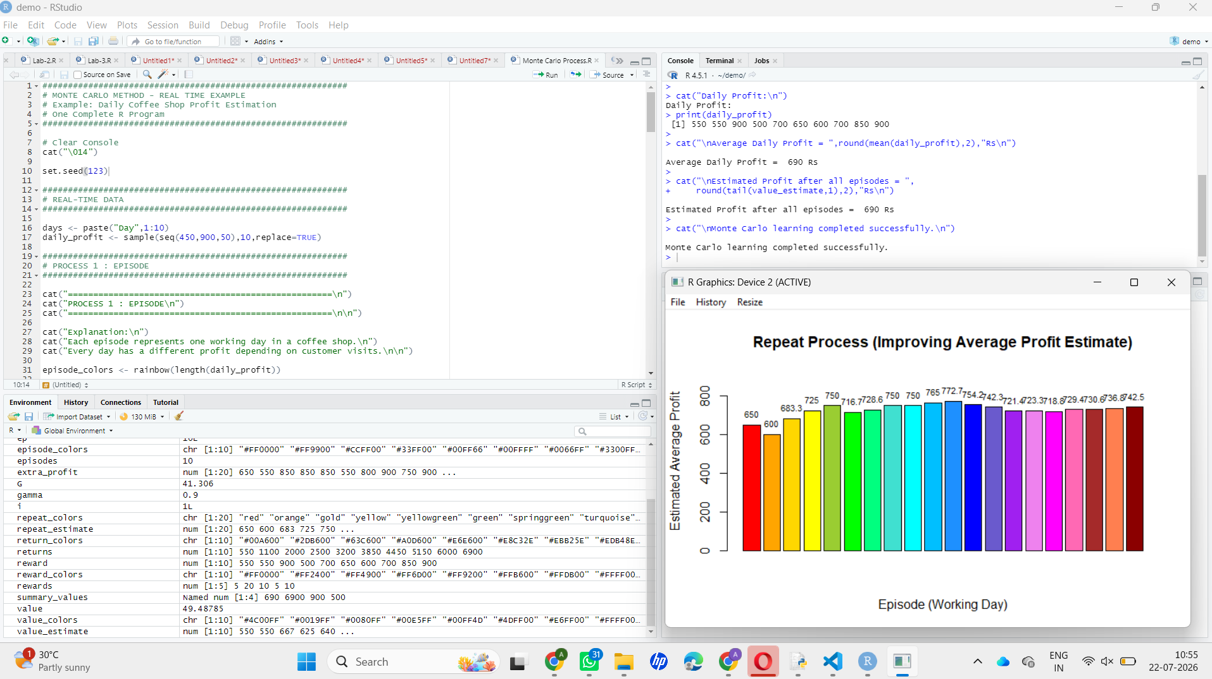

Visual result:
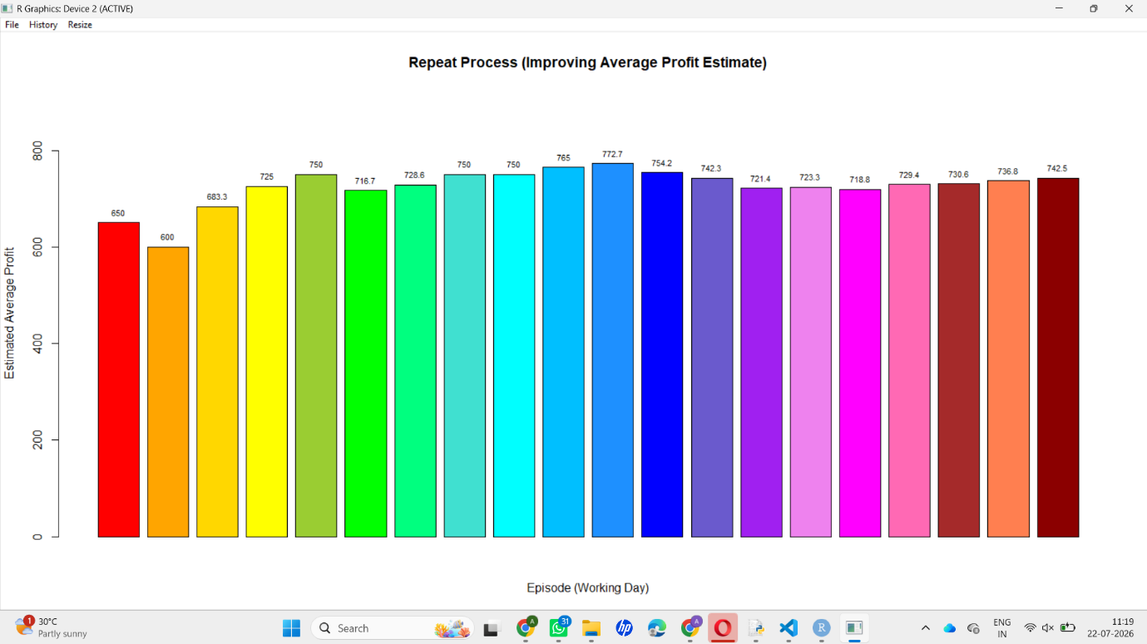

Summary result:

